Greek kylix κύλιξ, pl.. κύλικες) is a wine-drinking vessel of the 6th and 5th century BCE.
A broad shallow body with two horizontal symmetrical handles enabled the drinker to drink whilst recumbent, as was the case in the symposia, the Greek equivalent of a cocktail party. The almost flat interior circle on the interior base of the cup, called the tondo, was the primary surface for painted decoration in the Black-figure or Red-figure styles. As the representations would be covered with wine, the scenes would only be revealed in stages as the wine was drained. They were often designed with this in mind, with scenes created so that they would surprise or titillate the drinker as they were revealed. The word comes from the Greek kylix "cup," which is cognate with Latin calix, the source of the English word "chalice."Greek black glazed Stem Kylix dated to the mid 4th century.
The black glazed Kylix has a base ring stem and two handles 20.4 cm wide 7 cm high
An large elegant ancient Greek late Attic/Apulian blackware kylix, dating to approximately 420-350 B.C.
Two loop handles lie one on each side. The piece is decorated with a glossy black glaze. The central tondo is adorned with palmette decoration
Case no.:
Accession Number:
Formal Label:
Display Description:
LC Classification:
Date or Time Horizon:
Geographical Area:
Map:
GPS coordinates:
Cultural Affiliation:
Media:
Dimensions:
Weight:
Condition:
Provenance:
Discussion:
References:

A000-Eur-Greece-Kantharos-Red Figure-Ceramic-Hellenistic-350 BCE
Case no.: 4
Accession Number:
Formal Label: Eur-Greece-Kantharos-Red Figure-Ceramic-Hellenistic-350 BCE
Display Description:
Red Figure Kantharos shows two ladies of fashion with their hair tied in a bun.
Two high loop handles either side.
LC Classification:
Date or Time Horizon: 350 BCE
Geographical Area: Greece
Map:
GPS coordinates:
Cultural Affiliation: Hellenistic
Medium: ceramic, red figure
Dimensions: H 16.2cm
Weight:
Condition: replica
Provenance: Chersonesos, Crimea-Ukraine
Discussion:
References:

A000-Asia-Indus-Mohenjodaro-Vase-Terra cotta-2800 BCE
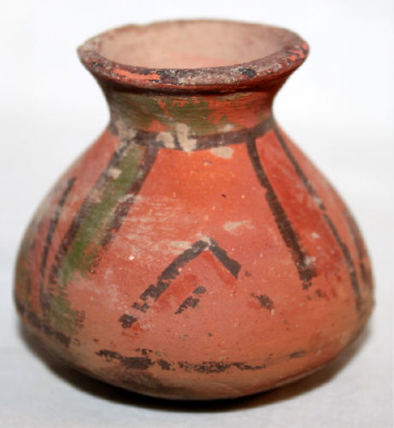
Case no.: 3
Accession Number:
Formal Label: Asia-Indus-Mohenjodaro-Vase-Terra cotta-2800 BCE
Display Description:
This orange slip terra cotta vase is decorated with a pyramidal design in four quadrants that suggests a temple complex. Such a design would add to our knowledge of the popular imaging of the above ground temple structures like that of Mohenjodaro’s citadel complex.
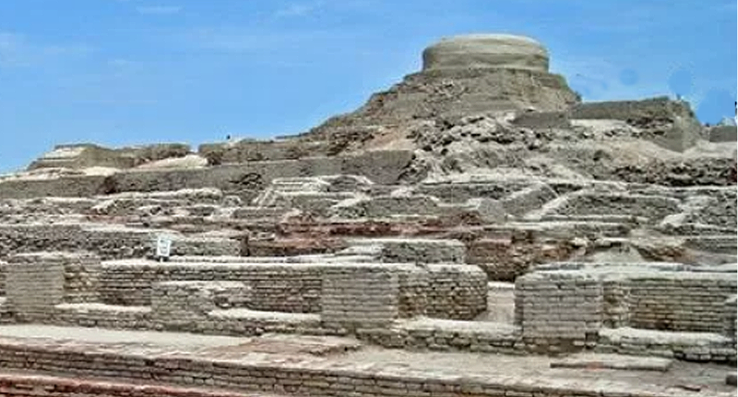
Mohenjodaro’s citadel complex, which is a fortress protecting the town, from the lower town, after https://i0.wp.com/www.saharab.com/wp-content/uploads/2018/03/facts-about-one-of-worlds-earliest-major-cities-mohenjo-daro.jpg?fit=736%2C527&ssl=1
LC Classification:
Date or Time Horizon: 2800 BCE
Geographical Area: Harappa
Map:
GPS coordinates:
Cultural Affiliation:
Media: orange slip terra cotta, black pigment
Dimensions: H 3 in
Weight:
Condition: original
Provenance:
Discussion:
References:

A000-Eur-Greece-Figure-Female, Standing-Terra cotta-Hellenistic-300 BCE
Case no.: 4
Accession Number:
Formal Label: Eur-Greece-Figure-Female, Standing-Terra cotta-Hellenistic-300 BCE
Display Description:
LC Classification:
Date or Time Horizon: Hellenistic-300 BCE
Geographical Area:
Map:
GPS coordinates:
Cultural Affiliation: Hellenistic-300 BCE
Medium: Terra cotta
Dimensions: H 10½ inches 26.5 cm
Weight:
Condition: original
Provenance:
Discussion:
References:
A000-Eur-Greece-Spindle Flask-Unguentarium-Terra cotta-Hellenistic-250 BCE
Case no.: 4
Accession Number:
Formal Label: Eur-Greece-Spindle Flask-Unguentarium-Terra cotta-Hellenistic-250 BCE
Display Description:
A Plain Ware, brownish clay, fusiform, spindle-shaped flask with a base and flared rim, rounded bi-conical body tapering to a slightly flared foot, very slightly concave cylindrical neck, wide-lipped rim. Unguentaria are small narrow-necked flasks for perfumed oils or unguents used throughout the Hellenistic period.
LC Classification:
Date or Time Horizon: Hellenistic-250 BCE
Geographical Area:
Map:
GPS coordinates:
Cultural Affiliation:
Medium: brownish terra cotta
Dimensions: H 4 in
Weight:
Condition: original
Provenance:
Discussion:
No slip. Wheelmade, wheelmarks visible.
References:

A000-Eur-Greece-Figurine-Apollo-Terra cotta-450 BCE
Case no.: 4
Accession Number:
Formal Label: Eur-Greece-Figurine-Apollo-Terra cotta-450 BCE
Display Description:
Apollo is depicted in this brown clay terracotta as an ideal kouros (κοuρος), a beardless, nude, athletic youth. He is presented frontally, with a chiton draped over his shoulders. His lips appear parted because Apollo functioned as a healer through song, called "paeαn" (παιάν), after the god Paean (Παιών-Παιήων), the physician of the Gods in the Iliad, who was derived from the Mycenean Pa-ja-wo (1900 BCE – ca. 1100 BCE) from Knossos, so his origins are very ancient. Apollo's practitioners or iatromonteis "seer-doctors" (ιατρομάντεις) used an ecstatic prophetic art (shamanism), which was the same as that used by the god at the Delphic Oracle. After ca. 400 BCE medicine and healing associated with Apollo were taken over by his son Asclepios and granddaughter Hygeia, who shared the epithet Paean, "the Healer." The original Hippocratic Oath began with the invocation "I swear by Apollo the Physician and by Asclepius and by Hygieia...". This figurine was probably used as a votive offering for healing and was probably sung to with the paeans the god had left to his "seer-doctors".
LC Classification:
Date or Time Horizon: 450 BCE
Geographical Area:
Map:
GPS coordinates:
Cultural Affiliation: Archaic Greece
Media: brown terra cotta
Dimensions: H 250 mm
Weight:
Condition: original
Provenance:
Discussion: This is a hollow figurine with a firing hole on base and back
References:

A000-Eur-Greece-Figurine-Aphrodite-Seated-Terra cotta-350 BCE
Case no.: 4
Accession Number:
Formal Label: Eur-Greece-Figurine-Aphrodite-Seated-Terra cotta-350 BCE
Display Description:
With clear majestic facial features the goddess is enthroned, wearing a chiton which covers her breasts with her feet resting on a footstool, her hands resting on her legs as though listening to a suppliant petitioner, who probably was beseeching her on matters of love, since votive figurines were offered to a deity devoted to a particular aspect of life.
LC Classification:
Date or Time Horizon: 350 BCE
Geographical Area: Archaic Greece
Map:
GPS coordinates:
Cultural Affiliation: Archaic Greece
Media: terra cotta
Dimensions: H 123 mm
Weight:
Condition: original
Provenance: previously on display at a museum in Israel.
Discussion: Firing hole on base;
References:
a similar example, lot 388, Sotheby's London Antiquities auction, 8 July, 1991 (est. 3,000 - 3,500).

A000-Eur-Magna Graecia-Figurine-Demeter-Seated-Terra cotta-550 BCE
Round firing hole on base. 97 mm. high.
Case no.: 4
Accession Number:
Formal Label: Eur-Magna Graecia-Figurine-Demeter-Seated-Terra cotta-550 BCE
Display Description:
From an area of southern Italy which was populated by Greek immigrants, this seated Demeter wears a chiton covering her body indicated by a red slip over which is a long himation gown, which runs close to her body. Covered by a veil, she projects an aura of serene, benevolent majesty, feet on a footstool, hands resting on her legs as though listening to a suppliant petitioner, who probably was beseeching her on matters of pregnancy and childbirth: votive figurines were offered to a deity devoted to a particular aspect of life.
LC Classification:
Date or Time Horizon:
Geographical Area:
Map:
GPS coordinates:Cultural Affiliation:
Media: terra cotta, Original black pigment can still be discerned in the mascara of her eyes, and the definition of her hands, legs and hair.
Dimensions:
Weight:
Condition:
Provenance:
Discussion:
References:

A000-Asia-Indus-Mehrgarh-Figurine-Avian-Terracotta-2800 BCE
Case no.: 3
Accession Number:
Formal Label: Asia-Indus-Mehrgarh-Figurine-Avian-Terracotta-2800 BCE
Display Description:
From one of the earliest Neolithic Indus Valley sites on "Kachi plain" in Balochistan, Pakistan with evidence of farming (wheat and barley) and herding (cattle, sheep and goats). Buff, terracotta fertility figurine, with mythical avian facial features and full hair, which hangs down her right shoulder in a long braid. A veil or headdress crowns her head laterally with her hair is exposed at back. Her large round eyes are deeply incised suggesting an owl-like countenance, possibly indicating omniscience, and her face is characteristically bird-like, with a nose in the shape of an owl's beak. Long, elegant legs bend slightly at the hip and knees. Legs end in delicate, tiny, three "toes" suggesting a bird's claw. Her shoulders are broad and square with her arms extending downwards and forward at her waist as though offering an answer to a suppliant petitioner: we can only imagine what the ancient donor wished for.
LC Classification:
Date or Time Horizon: Mehrgarh (Urdu: م‍ﮩ‍رگڑھ ), Period VII, 2800 – 2600 BCE
Geographical Area: Mehrgarh (Urdu: م‍ﮩ‍رگڑھ ), Period VII, 2800 – 2600 BCE
Map:
GPS coordinates:
Cultural Affiliation:
Media:
Dimensions: H 122 mm
Weight:
Condition: She has been repaired in several places as well as her right arm and foot.
Provenance:
Discussion:
References:

West-central Anatolian (now in Turkey), Phrygian terracotta figurine Matar Kubileya "Mountain Mother" ca. 800 BCE

This Matar Kubileya comes from the capital of Phrygia, Gordium (Greek: Γόρδιον, Górdion). She was later known as the Greek Κυβέλη, Kybele, and the Roman Cybele. Her oldest Anatolian cults were as a Great Mother associated with mountains, hawks and lions. In this unique terracotta figurine she wears a high mural headdress of the Phrygian capital Gordium, her place of origin. This headdress has two model bastions that were placed on either side of the city's entrance gate, which are still preserved at the archaeological site. This headdress indicates her role as protectress of the city. She is here portrayed in a flowing robe with a typically curled hair style. Here she displays a Semitic facial countenance. Later, her Phrygian cult was adopted and adapted by Greek colonists of Anatolian Asia Minor and was diffused to mainland Greece and Magna Graecia in the 6th century BCE. 178 mm. high.

Greek Terracotta Figurine of Terracotta Boar, 5th Century BCE
A solid terracotta figurine of a standing boar in an aggressive posture with moulded ears pointed snout and ridged back. There is a crack along the line where the two sides were originally joined together; a chip is missing from the back, above the hind quarters. The bottom part of the front end has been broken off and re-joined. The clay is dark buff with traces of white remain.
Originally, the boar was coated in white slip, but this has now been badly eroded.

terracotta pigs were a very popular votive along with cocks, doves, tortoises and other animals. Pigs were offered in sacrifice to Demeter and Persephone due to their sacred association with the animal. Terracotta equivalents were also dedicated at the sanctuaries of these deities. These animals were also found buried with the dead. Stylistically, very little changed regarding the making and decoration of these boars.

